Susan Kling, Co-Chairman

susangfwcwrwc@yahoo.com

Cindy Troutman-Myers, Co-Chairman

ctmyers@ptd.net

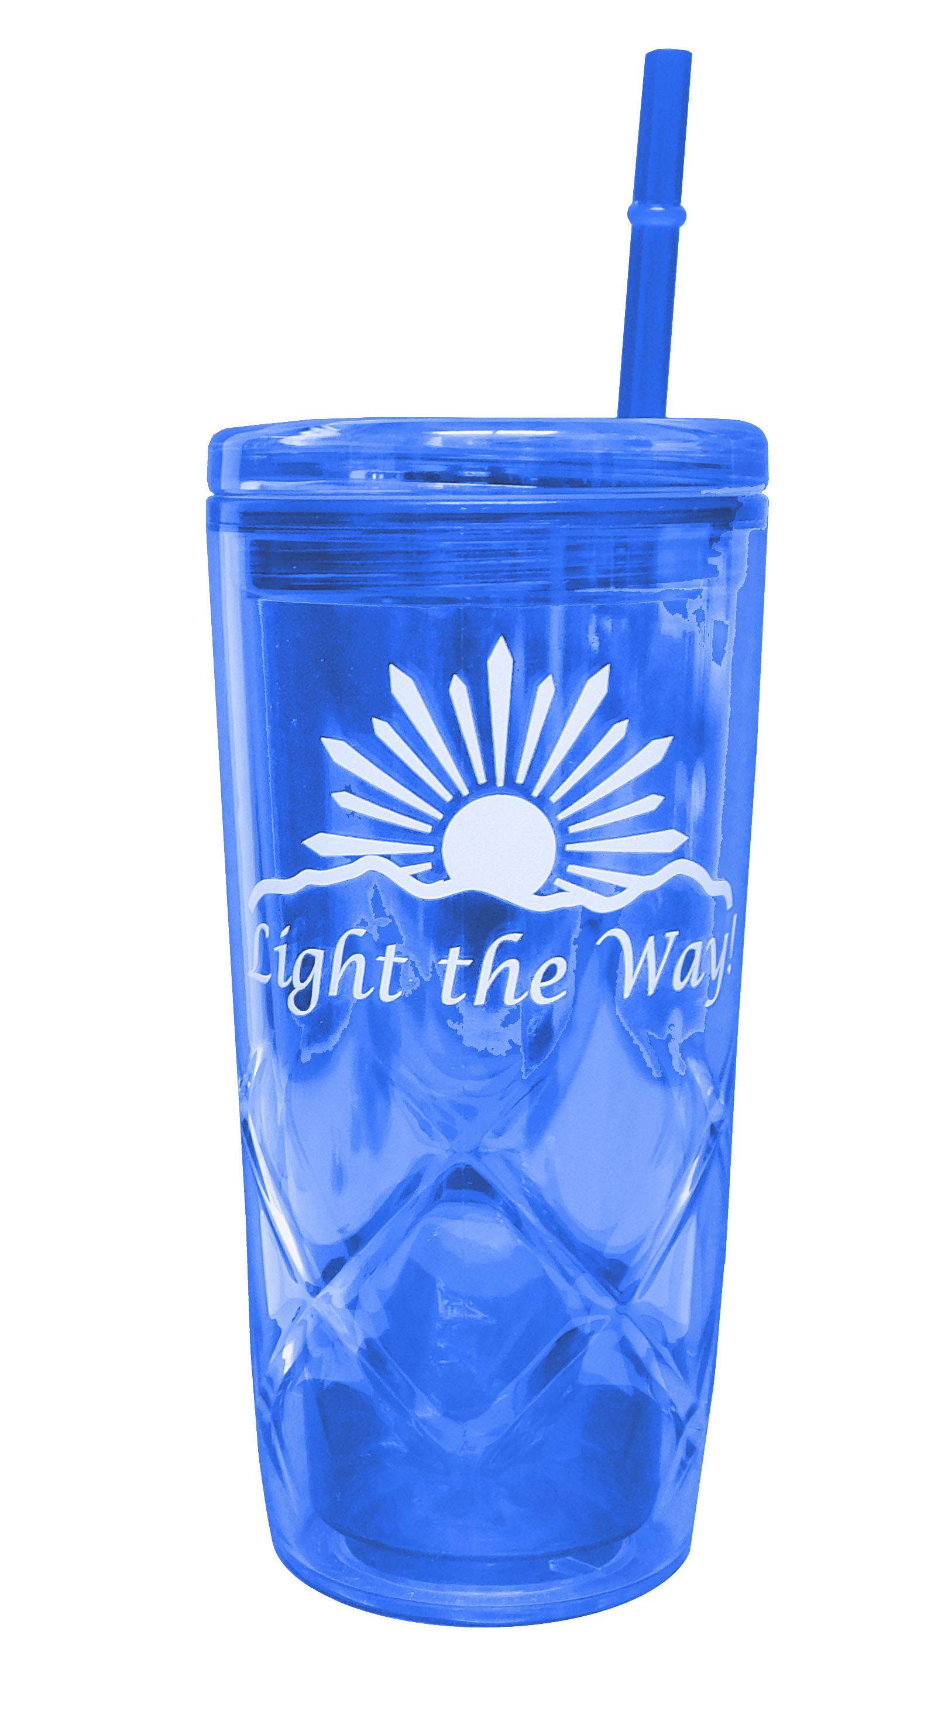

**2022-2024 FUNDRAISING ITEMS**

Travel Tumbler for Hot or Cold Drinks with Straw

Blue with “Light the Way” Logo in White

$11.32 + 0.68 tax = $12.00

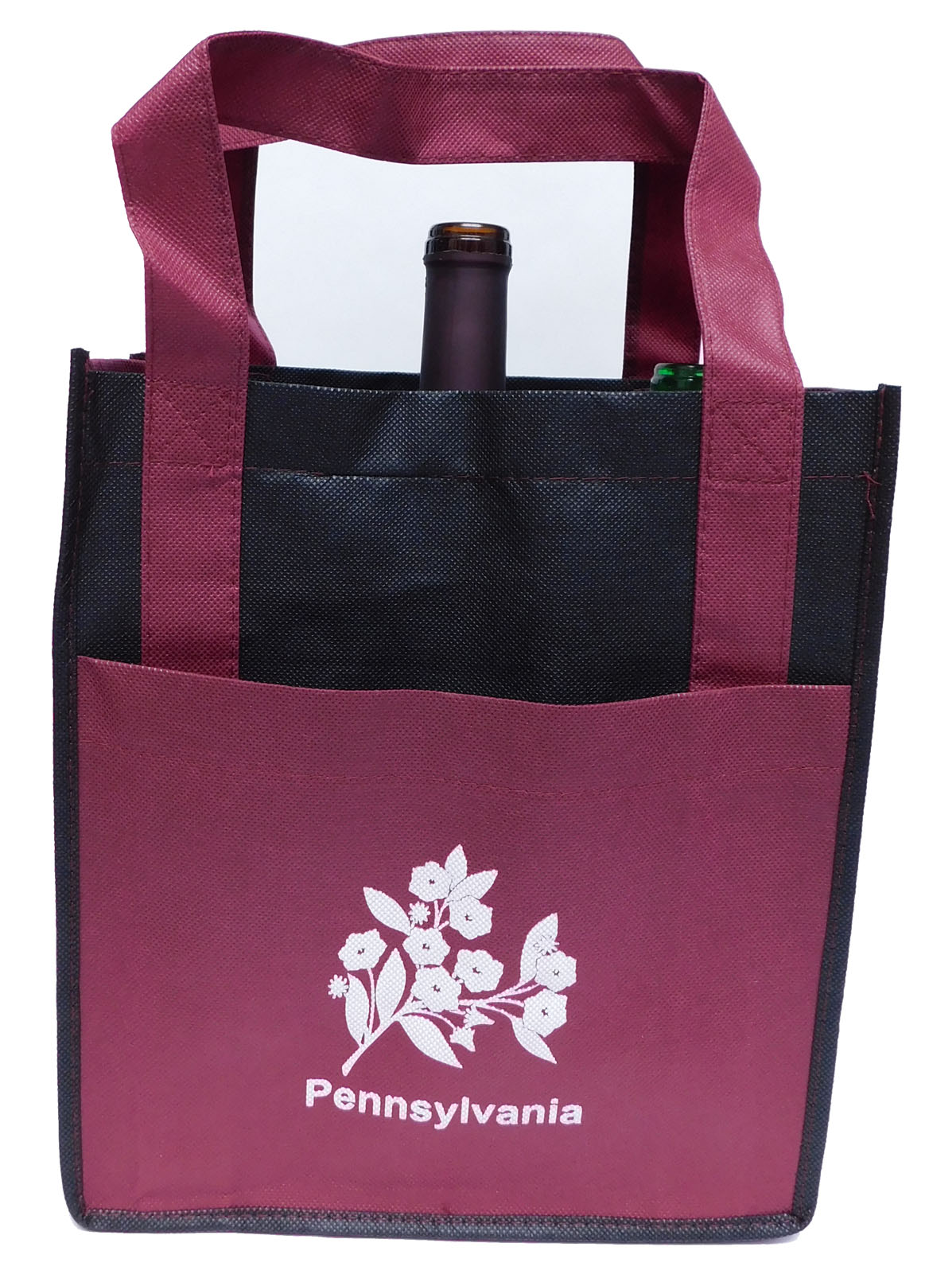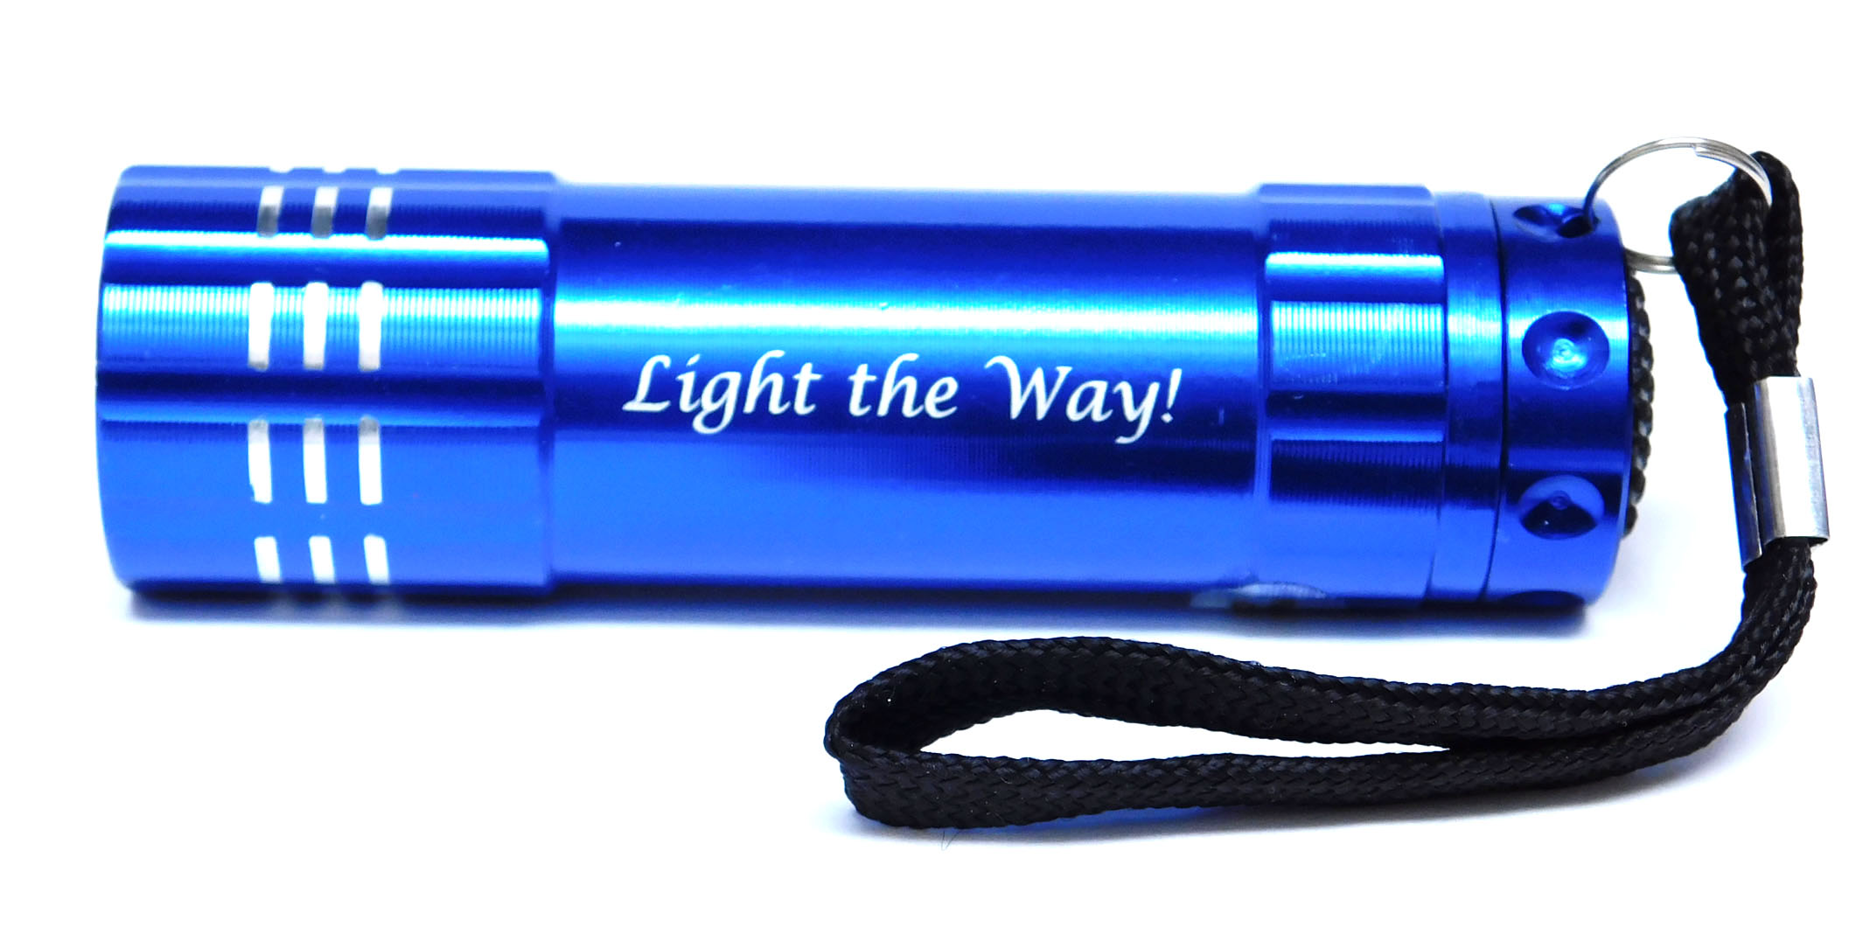

Toscano 6 Bottle Wine Tote

Burgundy with Pennsylvania Logo in White

$9.44 + 0.56 tax = $10.00

Pocket LED Flashlight

Blue with “Light the Way” in White

$7.55 + 0.45 tax = $8.00

State President’s Pin

$4.72 + 0.28 tax = $5.00

All items will be available at the upcoming district meetings. Please contact Cindy or Susan to place orders directly.