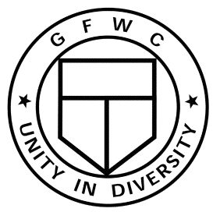
GFWC Pennsylvania Name Badge
Molly
Member

Available to Every Member

Only $16.00 each!!

GFWC Pennsylvania is offering its members a name badge that can be worn anywhere - any time. No pins. No sticky back. It uses a powerful magnet to stay in place with no damage to garments. The name badge, with our GFWC logo engraved on it, comes in brass finish. Your name, engraved as you specify, makes this the perfect item for club use. At events and meetings in your community, it will identify you as a member of GFWC & GFWC Pennsylvania.

Complete the form below and send, with your check payable to GFWC Pennsylvania to:

GFWC Pennsylvania Headquarters
4076 Market Street, Suite 211
Camp Hill, PA 7011-4200

- - - - - - - - - - - - - - - - - - - - - - - - - - - - - - - - - - - - - cut—along—line - - - - - - - - - - - - - - - - - - - - - - - - - - - - - - - - - - - - - - - - - - - - - - -

Name (typed or printed as you wish it to appear on badge):

____________________________________________________________________________________________
(If ordering more than one badge, please include typed list with names as they are to appear on badges.)

SHIP TO: ___________________________________________________________________________________

Address: ____________________________________________________________________________________

City: _______________________________________________ State _______ Zip Code ___________________

Contact telephone number: ________ - _________ - ______________ Email: _________________________________

___________ TOTAL number of badges ordered ____________ TOTAL Amount Enclosed.

Shipping and handling included in cost.
Delivery in approximately three (3) weeks.

This is not a fundraising item. It is offered at cost as a service to our members.

