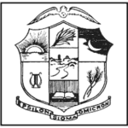**GFWC Epsilon Sigma Omicron** (ESO)

GFWC Pennsylvania, Kappa Chapter

Judi Stankowich, Chairman

8921 Smithfield Dr NW, Calabash, NC 28467

910-287-6156 judistankowich@atmc.net

**ESO**is an honorary educational society that is federation-supported and open to all GFWC club members. The GFWC Pennsylvania Kappa Chapter of ESO began in 1950. To become a member, complete the simple application and simply read!! Certificates are awarded for completed levels at the GFWC Pennsylvania Convention annually. ESO is one of the ***free*** benefits of belonging to a GFWC federated club.

Involve your club members. Who can read the most books during the year? Recognize her at a club meeting. Highlight a book read by a member at each meeting or include suggested books in your club newsletter. Have a trade books table at club meetings– members can bring some or take some.

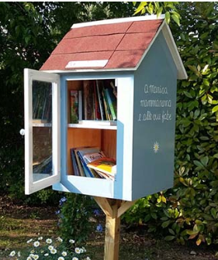Need a club project? Have you heard about Little Free Library Book Sharing Boxes? There are over 100,000 worldwide!!

Little Free Library is a nonprofit organization that inspires a love of reading, builds community, and sparks creativity by fostering neighborhood book exchanges around the world.

Through Little Free Library book exchanges, millions of books are exchanged each year, profoundly increasing access to books for readers of all ages and backgrounds.

Visit www.littlefreelibrary.org for more information.

**Interesting Facebook groups and pages:**

* GFWC 2020-2022 ESO Facebook Group
* The Lowcountry Book Club - people who like books about the geographic and cultural region along South Carolina's coast, including the Sea Islands.
* Friends and Fiction

**Books:**

* www.goodreads.com – find out about new books, what are authors saying?
* www.bookbub.com – Unbeatable ebook deals, updates from your favorite authors and handpicked recommendations.
* www.bookseriesinorder.com – like to read authors who write a series of books and want to read them in order – get the information here.